Schedule–Room 214–Friends & Ms. Toneri

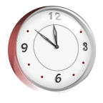 8:30 Morning Routines/Class Meetings/SEL

8:55 Language Arts Block-Reading Groups-Foundational Skills
Integrated Social Studies

10:00 Recess (Fridays 9:45-9:55)

10:10 Language Arts Block Continued

10:50 Writing or Science
Instruction, Small Groups, Games & Centers

11:35 Lunch & Recess

12:15 Class Meeting (SEL)

12:30 Mathematics

1:55-2:40 Specialists

Art - Mondays
PE - Tuesdays - Tennis shoes required Mondays
Library – Wednesdays – Bring library books to school.
Music – Thursdays
Rotations- Every Other Friday (10:09-11:13 a.m.)

Early Release @ 1:35 – Fridays

Dismissal 2:50 P.M.

